Write a program that creates a LinkedList object of 10 characters, then creates a second LinkedList object containing a copy of the first list, but in reverse order.

Program:

import java. util. \*;

public class LinkedListIm

{

public static void main(String args[])

{

LinkedList<Character> obj=new LinkedList<>();

LinkedList<Character> objrev=new LinkedList<>();

obj.addLast('a');

obj.addLast('b');

obj.addLast('c');

obj.addLast('d');

obj.addLast('e');

obj.addLast('f');

obj.addLast('g');

obj.addLast('h');

obj.addLast('i');

obj.addLast('j');

obj.addLast('k');

for (Character c:obj)

{

objrev.addFirst(c);

}

System.out.println("Printing First linkedlist");

for(Character c1:obj)

{

System.out.print(c1);

}

System.out.println("\nPrinting second linkedlist");

for(Character c1:objrev)

{

System.out.print(c1);

}

}

}

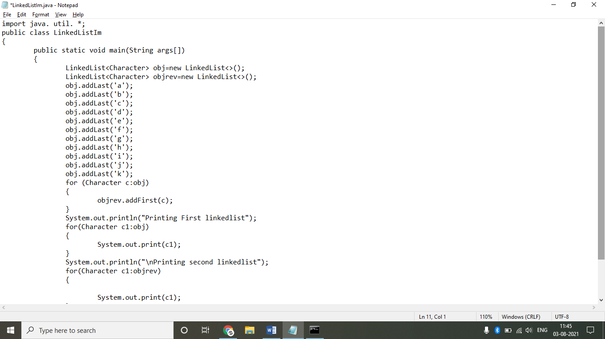

Output:

